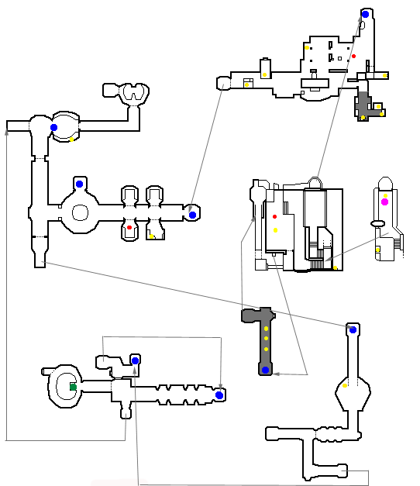
Level : | 1 | Menu : | NucleoLab |  | Character : |  | Korben
Inventory item : | Gun |  |  | 3 cards on ennemies
Enemies : | Lab scientists |  |  | Mutant of the lab |  |  | Nucleolab guardians

Mission : Korben must get into the Nucleolab to find the cellular reconstruction laboratory. Once there he must reactivate Leeloo's materialisation using the genetic card.

Start Arrival Inventory Item Checkpoint Secret
Card on ennemy

Level : | 2 | Menu : | N,Y,P,D, |  | Character : |  | Leeloo
Inventory item :
Enemies : | Cop with truncheon |  |  | Flying Cop |  |  | Hand fighting Mangalore

Mission : Korben has been arrested by the police. Leeloo must get into the police station and free Korben who is held in a cell.

Start Arrival Inventory Item Checkpoint Secret
Card on ennemy

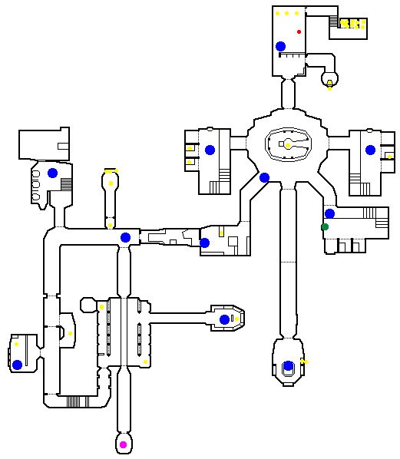

Level : | 2-bis | Menu : | N,Y,P,D, |  | Character : |  | Leeloo
Inventory item :
Enemies : | Cop with truncheon |  |  | Flying Cop |  |  | Hand fighting Mangalore

Mission : Leeloo has freed Korben, but the police station is now in a state of alert.Find a way out in less that 1 minute and 30 seconds otherwise they will both be trapped.

Start Arrival Inventory Item Checkpoint Secret
Card on ennemy

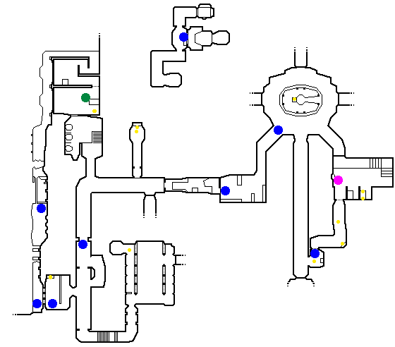

Level : | 3-1 | Menu : | Cornelius |  | Character : |  | Korben
Inventory item : | Electrogun |  |  | 4 cards on ennemies |  |  | Fire activator
Enemies : | Black cop with gun |  |  | White cop with gun |  |  | Zorg's man with gun

Mission : Father Cornelius holds the secret to the absolute weapon against Evil. Leeloo must find the Earth activator located in his apartment. Korben must bring the Fire activator to the priest's apartment.

Start Arrival Inventory Item Checkpoint Secret
Card on ennemy

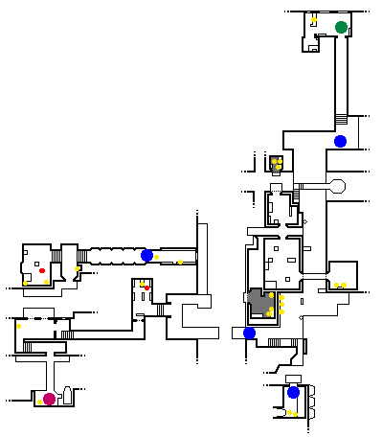

Level : | 3-2 | Menu : | Cornelius |  | Character : |  | Leeloo
Inventory item : | Earth Activator |  |  | 2 cards on ennemies
Enemies : | Cop with truncheon |  |  | White Zorg's man |  |  | Black Zorg's man

Mission : Father Cornelius holds the secret to the absolute weapon against Evil. Leeloo must find the Earth activator located in his apartment. Korben must bring the Fire activator to the priest's apartment.

Start Arrival Inventory Item Checkpoint Secret
Card on ennemy

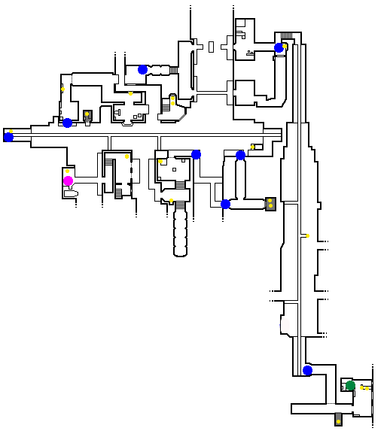

Level : | 4-1 | Menu : | Zorg's HQ |  | Character : |  | Korben
Inventory item : | ZF1 |  |  | Fhloston tickets
Enemies : | Zorg's man with gun |  |  | Spider |  |  | Medusa

Mission : Zorg, absolute evil's ally, has captured Cornelius. Korben and Leeloo must attack his headquarters in order to free their friend. On the way Leeloo must find the tickets to Fhloston Paradise and Korben must deactivate the headquarters' security system by neutralising the central computer.

Start Arrival Inventory Item Checkpoint Secret
Card on ennemy

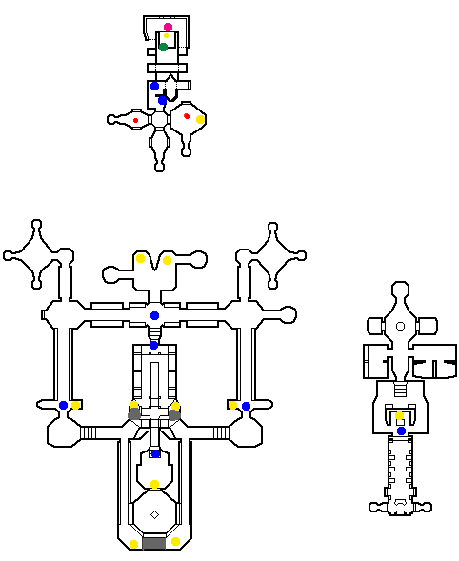

Level : | 4-2 | Menu : | Zorg's HQ |  | Character : |  | Leeloo
Inventory item : | 1 card on ennemi
Enemies : | Spider |  |  | Big white robot |  |  | Black Zorg's man

Mission : Zorg, absolute evil's ally, has captured Cornelius. Korben and Leeloo must attack his headquarters in order to free their friend. On the way Leeloo must find the tickets to Fhloston Paradise and Korben must deactivate the headquarters' security system by neutralising the central computer.

Start Arrival Inventory Item Checkpoint Secret
Card on ennemy

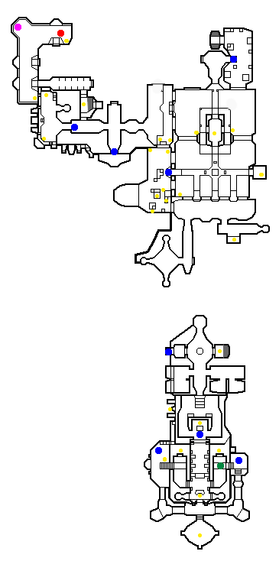

Level : | 5 | Menu : | Escape from Zorg's HQ |  | Character : |  | Leeloo
Inventory item :
Enemies :

Mission : By neutralising the central computer, Korben has set off a chain reaction that will destroy Zorg's headquarters. Fortunately for him, he is out of danger but Leeloo must find her way out of the building!

Start Arrival Inventory Item Checkpoint Secret
Card on ennemy

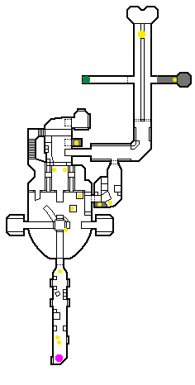

Level : | 6-1 | Menu : | Depths of NY |  | Character : |  | Korben
Inventory item : | Electrogun |  |  | ZF1 |  |  | 2 cards on ennemies
Enemies : | Black cop with gun |  |  | Mangalore with machine gun |  |  | Mangalore with 2 guns

Mission : The New York police are after Leeloo and Korben who have taken refuge in the depths of New York. They must both find ammunition, weapons and other items they need to get out of the area before they are captured.

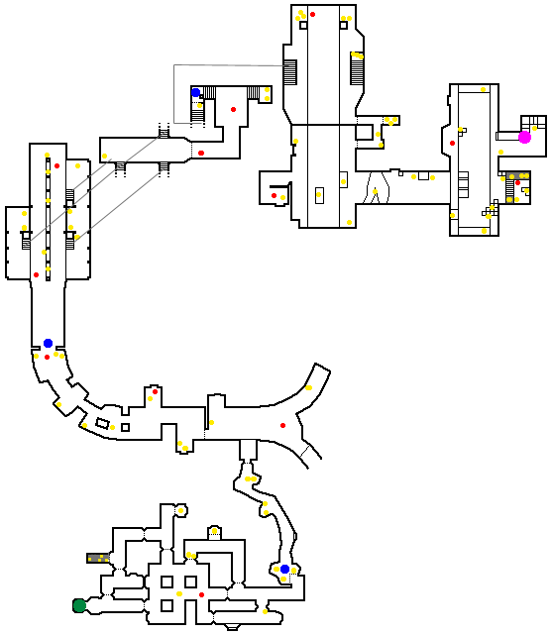
Start Arrival Inventory Item Checkpoint Secret
Card on ennemy

Level : | 6-2 | Menu : | Depths of NY |  | Character : |  | Leeloo
Inventory item : | 2 cards on ennemies |  |  | Part for the taxi |  |  | Leeloo Multipass
Enemies : | Cop with truncheon |  |  | Hand fighting Mangalore |  |  | Green sewers monster

Mission : The New York police are after Leeloo and Korben who have taken refuge in the depths of New York. They must both find ammunition, weapons and other items they need to get out of the area before they are captured.

Start Arrival Inventory Item Checkpoint Secret
Card on ennemy

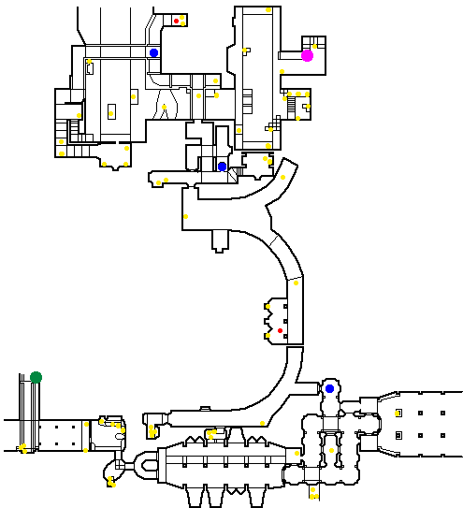

Level : | 7-1 | Menu : | The Factory |  | Character : |  | Korben
Inventory item : | Electrogun
Enemies : | Mangalore with machine gun |  |  | Sewer alien |  |  | Big sewer monster

Mission : Leeloo and Korben have escaped from the New York police by hiding in an disused factory in which Korben must locate a taxi while Leeloo looks for the Water element.

Start Arrival Inventory Item Checkpoint Secret
Card on ennemy

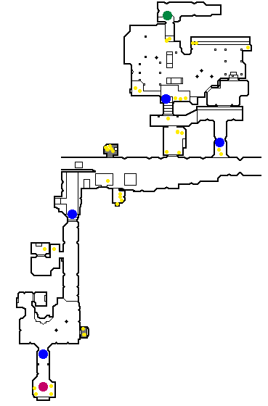

Level : | 7-2 | Menu : | The Factory |  | Character : |  | Leeloo
Inventory item : | Element water
Enemies : | Green sewers monster |  |  | Sewers alien |  |  | Big sewer monster

Mission : Leeloo and Korben have escaped from the New York police by hiding in an disused factory in which Korben must locate a taxi while Leeloo looks for the Water element.

Start Arrival Inventory Item Checkpoint Secret
Card on ennemy

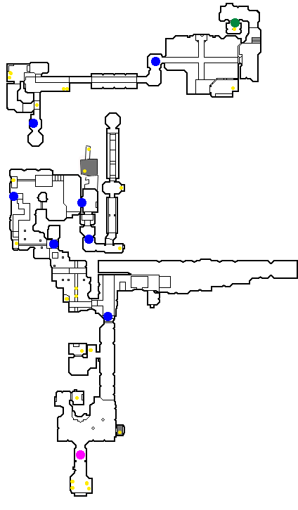

Level : | 8-1 | Menu : | Astroport |  | Character : |  | Korben
Inventory item : | Water activator |  |  | 1 card on ennemi
Enemies : | Black cop with gun |  |  | Mangalore with machine gun |  |  | Flying cop

Mission : Leeloo and Korben must now find a way into the Astroport. Once inside they must look for the space shuttle and Korben must find the Water activator.

Start Arrival Inventory Item Checkpoint Secret
Card on ennemy

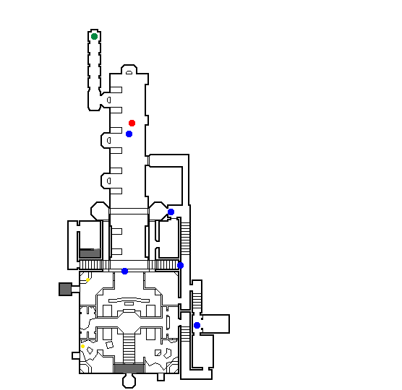

Level : | 8-2 | Menu : | Astroport |  | Character : |  | Leeloo
Inventory item : | 1 card on ennemi
Enemies : | Cop with truncheon |  |  | Hand fighting Mangalore |  |  | Flying Cop

Mission : Leeloo and Korben must now find a way into the Astroport. Once inside they must look for the space shuttle and Korben must find the Water activator.

Start Arrival Inventory Item Checkpoint Secret
Card on ennemy

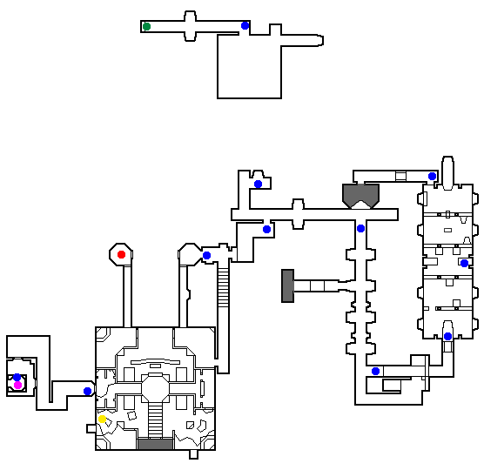

Level : | 9 | Menu : | Call from Zorg |  | Character : |  | Korben
Inventory item :
Enemies :

Mission : The telephone boxes in the Astroport have been boobytrapped by the evil Zorg. Korben must secure the area by destroying the phones that successively ring. You must do this quickly, very quickly!

Start Arrival Inventory Item Checkpoint Secret
Card on ennemy

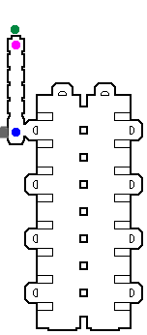

Level : | 10-1 | Menu : | Fhloston flight |  | Character : |  | Korben
Inventory item : | 1 card on ennemi
Enemies : | Hand fighting Mangalore |  |  | Mangalore with 2 guns |  |  | Mangalore with machine gun

Mission : Korben and Leeloo have succeeded in getting onto the shuttle for Fhloston Paradise but the Mangalores have stopped the engines and taken the pilots hostage. Leeloo must save them by liberating the cockpit while Korben reactivates the engines in the machine room.

Start Arrival Inventory Item Checkpoint Secret
Card on ennemy

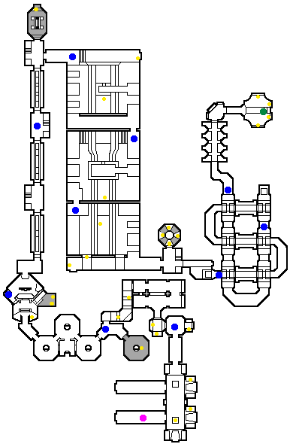

Level : | 10-2 | Menu : | Fhloston flight |  | Character : |  | Leeloo
Inventory item : | 1 card on ennemi
Enemies : | Hand fighting Mangalore |  |  | Mangalore with 2 guns |  |  | Mangalore with machine gun

Mission : Korben and Leeloo have succeeded in getting onto the shuttle for Fhloston Paradise but the Mangalores have stopped the engines and taken the pilots hostage. Leeloo must save them by liberating the cockpit while Korben reactivates the engines in the machine room.

Start Arrival Inventory Item Checkpoint Secret
Card on ennemy

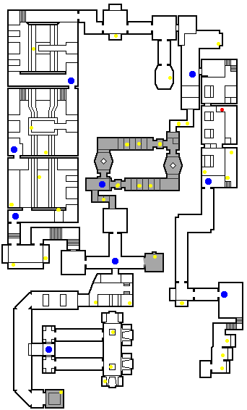

Level : | 11-1 | Menu : | Fhloston Paradise |  | Character : |  | Korben
Inventory item : | Zorg Card |  |  | ZF1
Enemies : | Mangalore with machine gun |  |  | Zorg's man with gun |  |  | Zorg with the ZF1

Mission : Zorg and the Mangalores have arrived and are wreaking panic on Fhloston Paradise. Zorg plans to destroy the sumptuous vessel as soon as he has gathered the stones. Korben must follow him to get the card to deactivate the bombs while Leeloo looks for the Air element that is hidden in the vessel.

Start Arrival Inventory Item Checkpoint Secret
Card on ennemy

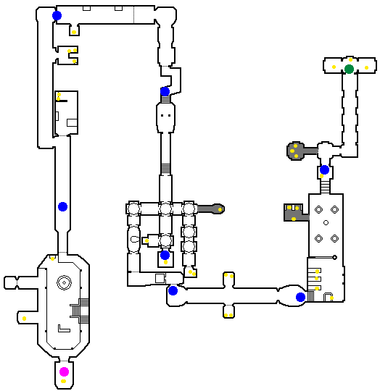

Level : | 11-2 | Menu : | Fhloston Paradise |  | Character : |  | Leeloo
Inventory item : | Element air
Enemies : | Black Zorg's man |  |  | White Zorg's man |  |  | Hand fighting Mangalore

Mission : Zorg and the Mangalores have arrived and are wreaking panic on Fhloston Paradise. Zorg plans to destroy the sumptuous vessel as soon as he has gathered the stones. Korben must follow him to get the card to deactivate the bombs while Leeloo looks for the Air element that is hidden in the vessel.

Start Arrival Inventory Item Checkpoint Secret
Card on ennemy

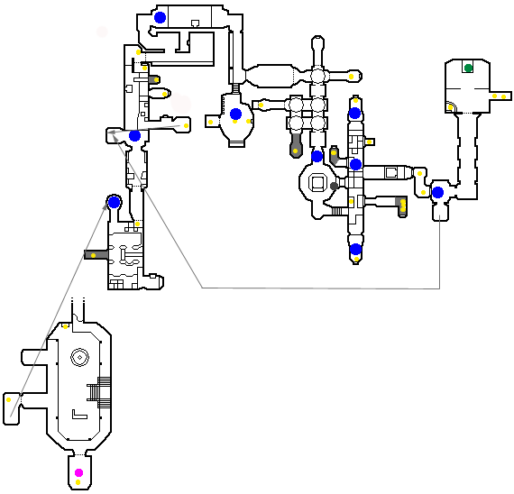

Level : | 12-1 | Menu : | Machine room |  | Character : |  | Korben
Inventory item : | ZFX Energy cells |  |  | 3 cards on ennemies
Enemies : | Zorg's man with gun |  |  | Black Zorg's man |  |  | Spider

Mission : There is not much time left as Ultimate Evil is now near Earth. Korben must find an energy cell to start a rescue shuttle to escape Fhloston Paradise. Leeloo continues to search for the elements, now looking for the fire stone.

Start Arrival Inventory Item Checkpoint Secret
Card on ennemy

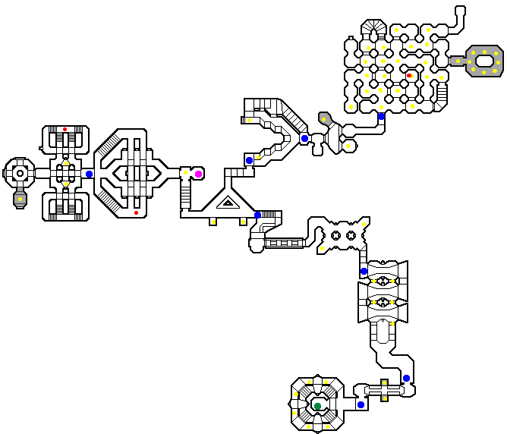

Level : | 12-2 | Menu : | Machine room |  | Character : |  | Leeloo
Inventory item : | Element fire |  |  | 3 cards on ennemies
Enemies : | Zorg's man with gun |  |  | Black Zorg's man |  |  | Spider

Mission : There is not much time left as Ultimate Evil is now near Earth. Korben must find an energy cell to start a rescue shuttle to escape Fhloston Paradise. Leeloo continues to search for the elements, now looking for the fire stone.

Start Arrival Inventory Item Checkpoint Secret
Card on ennemy

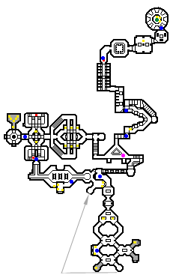

Level : | 13 | Menu : | Free Cornelius |  | Character : |  | Korben
Inventory item : | 4 cards on ennemies
Enemies : | Mangalore with 2 guns |  |  | Mangalore with machine gun

Mission : The Mangalores have attacked the Fhloston security centre and taken Cornelius hostage in order to recover the stones. They have put Cornelius in the reactor and Korben has 5 minutes to save him and stop the reactor before he dies!

Start Arrival Inventory Item Checkpoint Secret
Card on ennemy

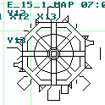

Level : | 14-1 | Menu : | Bomb alert |  | Character : |  | Korben
Inventory item :
Enemies : | Hand fighting Mangalore |  |  | Mangalore with 2 guns |  |  | Mangalore with machine gun

Mission : Zorg is implementing his fiendish plan by boobytrapping the Opera with a time bomb. Korben must activate the electronic posts hidden in the building in order to delay the countdown and then find a rescue shuttle to escape! Before escaping with Korben, Leeloo must get the Mondoshawan key and the Air activator for the Egyptian temple.

Start Arrival Inventory Item Checkpoint Secret
Card on ennemy

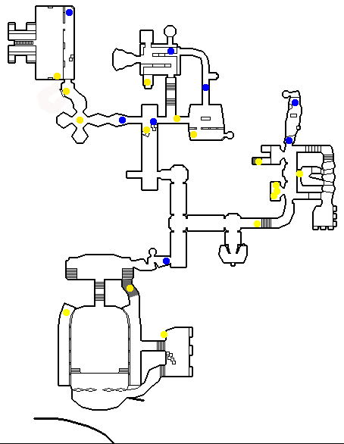

Level : | 14-2 | Menu : | Bomb alert |  | Character : |  | Leeloo
Inventory item : | Mondoshawan key |  |  | Air activator |  |  | 1 card on ennemi
Enemies : | Hand fighting Mangalore |  |  | Mangalore with 2 guns |  |  | Mangalore with machine gun

Mission : Zorg is implementing his fiendish plan by boobytrapping the Opera with a time bomb. Korben must activate the electronic posts hidden in the building in order to delay the countdown and then find a rescue shuttle to escape! Before escaping with Korben, Leeloo must get the Mondoshawan key and the Air activator for the Egyptian temple.

Start Arrival Inventory Item Checkpoint Secret
Card on ennemy

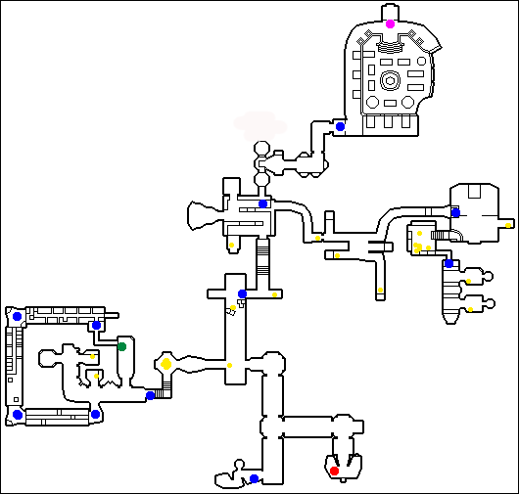

Level : | 15-1 | Menu : | Egyptian temple |  | Character : |  | Korben
Inventory item :
Enemies : | Mangalore with machine gun |  |  | Egyptian robot |  |  | Egyptian enemi

Mission : Arriving in Egypt, Leeloo leaves in search of the last sacred stone, the Earth element. Once she has the four elements Leeloo must enter the sarcophagus room accessed with the Mondoshawan key. Korben must find the secret stones to the temple and activate them. Only then can he finally activate the elements and save the planet from Absolute Evil.

Start Arrival Inventory Item Checkpoint Secret
Card on ennemy

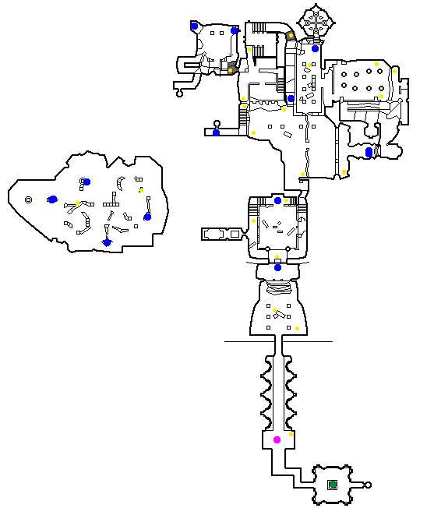

Level : | 15-2 | Menu : | Egyptian temple |  | Character : |  | Leeloo
Inventory item : | Element earth
Enemies : | Hand fighting Mangalore |  |  | Egyptian robot |  |  | Egyptian enemi

Mission : Arriving in Egypt, Leeloo leaves in search of the last sacred stone, the Earth element. Once she has the four elements Leeloo must enter the sarcophagus room accessed with the Mondoshawan key. Korben must find the secret stones to the temple and activate them. Only then can he finally activate the elements and save the planet from Absolute Evil.

Start Arrival Inventory Item Checkpoint Secret
Card on ennemy

